# OrphanAide

# Software Requirement Specifications

**Team Members**

|  |  |
| --- | --- |
| Aditya Srivastava | **1910110034** |
| Akansh Mittal | **1910110039** |
| Prabhat Kumar Singh Gaur | **1910110272** |

**TABLE OF CONTENTS**

1. **Introduction**
   1. Purpose
   2. Scope
   3. Product Overview
   4. Contact information/SRS team members
2. **Overall Description**
   1. Product Perspective
   2. Product Functions
   3. User characteristics
   4. Constraints

#### Assumptions and Dependencies

1. **External Interface Requirements**
   1. User Interfaces
   2. Hardware Interfaces
   3. Software Interfaces
   4. Communication Interfaces
2. **System Features**
   1. Display of Orphanages
   2. Security Measure
      1. Sign-in and Sign-up
      2. Orphanage Validation
   3. Secure Transactions
3. **Other Non-functional Requirements**
   1. Performance Requirements
   2. Safety Requirements
   3. Security Requirements
   4. Software Quality attributes
4. **INTRODUCTION**
   1. **Purpose**

A full-fledged web application where the donor could see all orphanages and search them based on the respective cities and donate to that orphanage.

Our product aims to target people who are willing to donate to orphanages. This app makes it easy and convenient for them to donate through the online method by just scrolling through the list of orphanages that our web app offers. It also provides hassle-free donation transactions to approved orphanages with the ability to accept online donations.

**Intended audience:** - People who want to provide donations to the orphanages for the betterment of orphan children.

* 1. **Scope**

The product is titled ‘**OrphanAide**’.

The product will perform the following tasks:

● To help people, donate to the orphanage of their choice by browsing through several orphanages made available on the website.

● Login or Signup as a user to donate to orphanages or log in as admin to approve any orphanage that the admit finds eligible to put up on the website for donation.

● Separate login for orphanages to send requests to get approval from the admin, to receive donations from our web application after a thorough verification by the administrators.

● A news section shows currently affected places due to some natural disaster or any other reason where more donations might be needed to tackle such calamities.

* 1. **Product Overview**
* **Problem Statement:** We scoured the internet and discovered that most of the websites dedicated to orphanage donations were organization-specific. As a result, a potential contributor would have to locate the organization and then browse for its contribution webpage, which might be time-consuming. Furthermore, there was no such portal where a donor could search for all orphanages, pick their preferred one, and contribute from there.
* **Solution:** We considered building a platform where donors could view all orphanages, search for them based on their cities, and donate to the orphanage of their choice. The application also offers a news area so donors may discover which cities are in most need of assistance and could donate accordingly.
  1. **Contact information**
* Aditya Srivastava (Email ID: as369@snu.edu.in)
  + Role: Designer
* Akansh Mittal (Email ID: am973@snu.edu.in)
  + Role: Developer
* Prabhat Kumar Singh Gaur (Email ID: ps827@snu.edu.in)
  + Role: Tester

1. **OVERALL DESCRIPTION**
   1. **Product Perspective**
      1. **Hardware Specifications**
         1. Hard disk:The backend connectivity of the database requires a hardware configuration via internet connectivity. It makes the database system fast and efficient.
         2. The system must interface with the standard input device, that is, keyboard and mouse.
      2. **Software Specifications**
         1. Front-End: ReactJS
         2. Back-End: Firebase

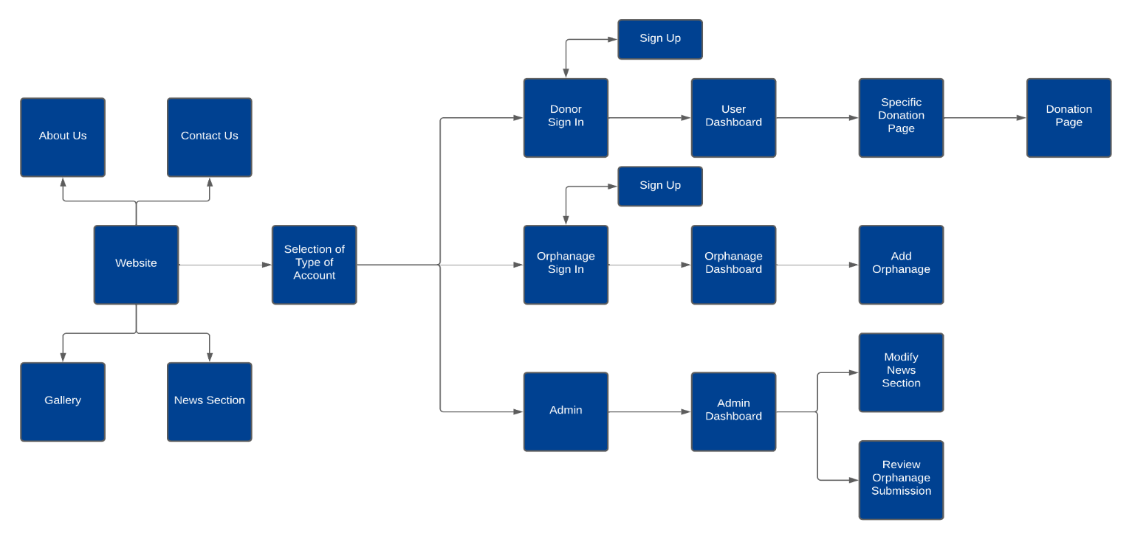

**Product Flow**

* 1. **Product Functions**

* Login screens for users, admins, and orphanages.
* Orphanage locator functionality.
* Donation to a particular orphanage.
* News section to know about current orphanage news.
* Orphanage review functionality when a new orphanage wants to join the platform.
  1. **User characteristics**
  + The application is designed in such a way that its user would not need any technical knowledge for accessing it.
  + The application is very user friendly; the user can access any feature of it easily.
  + The application is fully responsive so that the user can use it easily irrespective of device.
  1. **Constraints**
* Currently, the application is working on dummy data as there is no tie-up with real orphanages yet.
* Payment transactions would be a dummy for now.

**2.5 Assumptions and Dependencies**

* For now, no quantitative measures have been imposed on the application in terms of speed and scalability although it is implied that all functions will be optimized with respect to speed and scalability.

1. **EXTERNAL INTERFACE REQUIREMENT**

**3.1 User Interfaces**

A user should be provided with an interface that would be very user-friendly so that no extra technical knowledge would be needed to run the web app. The interface should also be equipped with all the modern UX features for a smooth and seamless experience. The platform would be fully responsive to ensure that the user can access the web app from anywhere irrespective of the device he/she equips. The following screens would be provided:

* Front Screen consisting of the navigation bar with news, gallery, about us, contact us and Login would be displayed along with some blogs and a few pictures.
* Login Screen would be there where the user can either sign in with his/her credentials or register if new.
* User Dashboard Screen would be provided on successful login where a list of orphanages would be displayed, user can check his/her donations till now and orphanage locator option would be displayed. Users would be able to donate to any of the orphanages and would then be redirected to the payment gateway.
* Admin Dashboard Screen would be provided if logged in as admin. Add and review orphanages and modify news section functionality would be available.
* Orphanage Dashboard Screen would be provided if logged in as an orphanage manager. Same as user dashboard except no donate option and added “add orphanage” feature and later send details for review to the admin.
* News Section Screen would be provided to let users have an idea about which orphanage has been affected the most by any natural disaster or any orphanage-related news.
* About us and Contact us Screen would be provided if a user or an orphanage will have any kind of query, they might contact the team.

**3.2 Hardware Interfaces**

* Any device, for example, mobile phones, laptops, desktops, tablets, iPad with a smooth internet connection would be required.

**3.3 Software Interfaces**

* Chrome browser version > 49 would be needed for Chrome users.
* Mozilla Firefox version > 44 would be needed for Firefox users.
* Safari browser version >= 11 would be needed for Safari users.
* Database of users and orphanages connected via Firebase.

**3.4 Communication Interfaces**

* On sign-up, authentication mail is sent to the user to check whether the user is valid or not. Once the validation check is done, the user can visit the dashboard.

1. **SYSTEM FEATURE**

**4.1 Display of Orphanage**

* When any user enters their dashboard, they will be able to see a list of all the orphanages that are affiliated with us. We receive the data of all the orphanages from the database which is shown to the user in the form of cards for easy access.
* The user can also search the various orphanages based on the location, in the back-end, the programs filter all the matching records and then show those to the user.

**4.2 Security Measure**

**4.2.1 Sign-in and Sign-up**

* For the user to access our application, they need to verify their identity. They need to sign up with a strong password and non-existing email ids. After registration, an email verification will be sent to their registered email.
* Before verifying their identity, they will not be able to log in. This will ensure that no user can access our website freely protecting it from any fraudulent activity.

**4.2.2 Orphanage Validation**

* + - This feature ensures that no false organization can take money from the user.
    - Whenever someone signs in as an orphanage, to add their orphanage to the application they will be required to put out a detailed description of their organization including name, address, location, number of children, the status of the orphanage (whether they are in a bad condition and are in a need of urgent money or they just want their children to be in a better condition), their registration id.
    - After submission, their information will be sent to the admin who will review the application, send their people to check the orphanage and after that, he will decide on whether that orphanage should be available on the application or not.

**4.3 Secure Transactions**

* When any donor wants to donate a specific amount to any organization then we will take the amount from the user and through the back end, the money will be transferred to the organization’s account using “Stripe” which is a payment processing software that keeps track of all the transactions to ensure security which could be checked by the admin in case of any difficulties.

1. **NON - FUNCTIONAL REQUIREMENTS**

**5.1 Performance Requirements**

* The system must be interactive, and the delays involved must be less. So, in every action, the response of the system has no immediate delays. In the case of scrolling through the list of orphanages, there should be a delay of no more than 3 seconds before the next page of orphanages is displayed otherwise our people’s donating experience is affected. The orphanage review should be placed in pending approval for the admin and be visible to the admins in less than 1 second to review the orphanage. Accepted Orphanage requests will be added to the database without any delay. Also, when connecting to the Firebase, the delay to make a successful connection should be less for effective real-time communication.
* The product is safe, reliable, and fast. For signup, just filling in the details is all and a new account will be created. For login, only the email and password are needed (created by the user during sign-up) and the login, as well as sign-up, are hassle-free and secure.

**5.2 Safety Requirements**

* The web application is harmless to the environment and does not violate any safety regulations. The browsing menu will feature a flexible font that may be zoomed so that the eyes are not stressed.

**5.3 Security Requirements**

* The application/product is secure. After a successful sign-up, the user needs to verify their email and then sign in to use further components of the application. Only after a successful login, the user shall be permitted to reach the dashboard. Changing the URL does not allow the user to reach the dashboard of the application.
* Users' sensitive information, as well as inventory, should be safeguarded from hackers, therefore appropriate and encrypted login authentication for donors, orphanages, and administrators is required.
* To minimize disruptions in collecting orphanage requests and charging donations, information should be securely delivered to Firebase without any modifications in data.

**5.4 Software Quality Requirements**

* **Reusability:** Current version of the applications can be used in the future with more functionality added.
* **Testability:** All the requirements are fulfilled, response time is low, and all functions are working perfectly in the web application.
* **Usability:** The interface of the application is easy to use. It would not be complex since users, orphanages, and administrators have separate login dashboards, so the interface should be simple.
* **Flexibility:** If the need arises in the future, the application can be modified to change the requirements.